LM339 IC
CP033
Image:
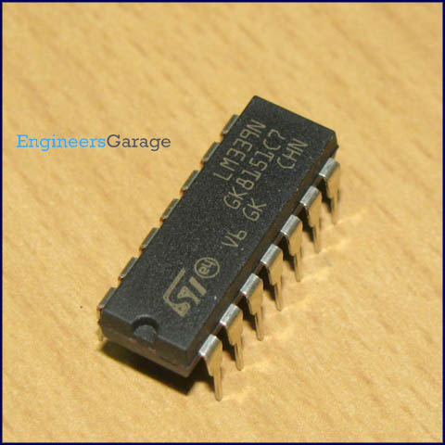
DataSheet:
LM339.pdf
LM339 is a comparator IC with four inbuilt comparators. A comparator is a simple circuit that moves signals between the analog and digital worlds. It compares two input voltage levels and gives digital output to indicate the larger one. The two input pins are termed as inverting (V-) and non-inverting (V+). The output pin goes high when voltage at V+ is greater than that at V-, and vice versa. In common applications, one of the pins is provided with a reference voltage and the other one receives analog input from a sensor or any external device. If inverting pin (V-) is set as reference, then V+ must exceed this reference to result in high output. For inverted logic, the reference is set at V+ pin.
Pin Diagram:
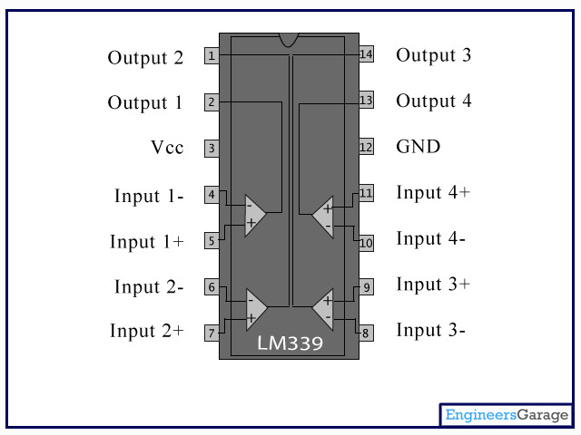
Pin Description:
Pin No | Function | Name
1 | Output of 2nd comparator | Output 2
2 | Output of 1st comparator | Output 1
3 | Supply voltage; 5V (+36 or ±18V) | Vcc
4 | Inverting input of 1st comparator | Input 1-
5 | Non-inverting input of 1st comparator | Input 1+
6 | Inverting input of 1st comparator | Input 2-
7 | Non-inverting input of 2nd comparator | Input 2+
8 | Inverting input of 3rd comparator | Input 3-
9 | Non-inverting input of 3rd comparator | Input 3+
10 | Inverting input of 4th comparator | Input 4-
11 | Non-inverting input of 4th comparator | Input 4+
12 | Ground (0V) | Ground
13 | Output of 4th comparator | Output 4
14 | Output of 3rd comparator | Output 3

